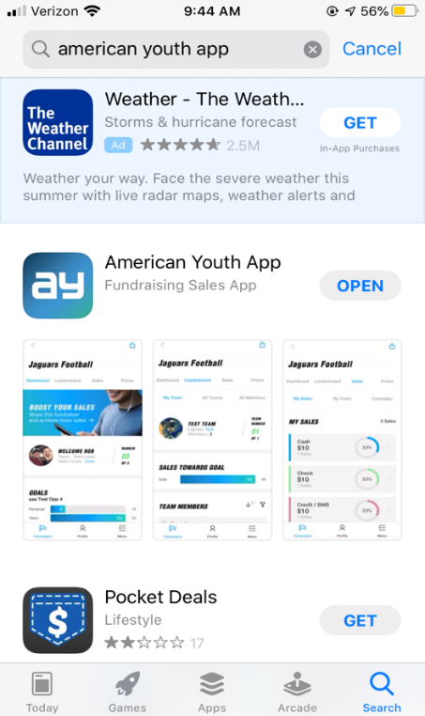
American Youth App Instructions

- Go to the App store on your iPhone or Android and download the “American Youth App” it’s the only app in there that’s titled that way. We’ve attached a photo to show what it looks like.

- When the App is downloaded onto your phone, click on the app and it will take you to the sign in page. On the bottom of the page it reads “Don’t have an account? Sign up” Click that and register with an email and password. If you registered last year, you can use the same account.

- Once registered, the app will ask for a campaign code. Enter hi8is which is our code for the 2023 season. Once you’re logged into the app with the code you will never be logged out unless done manually. Athletes who already have the app downloaded click on “Add New” on the top right of the campaign page to add the new code. Make sure you are completely backed out of previous football or track fundraiser campaigns.

- Once in the app, players can start sending the donation link via text message and email to friends and family to donate to the campaign. Click the send/manage invites button, then select send new invites to send out the link via Text messages and Emails. Donations are all tracked in the app as well as a team link page. Families have the ability to share the links on Twitter and Facebook as well. Audit reports can be sent to Boosters and Head Coach at Any time.

- 80/20 split for the programs and AY covers the credit card processing fees!!

